Stuff B Gone!

**Objectives:**

1. Create Database Triggers
2. Use Lab4.sql to create and populate the tables

#### Requirements:

Create the following SQL Database Triggers:

1. Create a trigger called **Lab4Q1** to ensure that the category cost will not increase by more than 15%. If this happens raise an error and do not allow the increase.  
   (**3.5 Marks**)
2. Create a trigger called **Lab4Q2** to ensure that a staff member cannot be assigned to a consignment agreement unless that staff member is in the 'Sales' StaffType. If this happens, raise an error, and do not allow the transaction to proceed.  
   (**3 Marks**)
3. Create a trigger called **Lab4Q3** on the ConsignmentDetails that prevents any modifications to the composite PK. In other words, do not allow a ConsignmentID or LineNumber to be changed. This restriction should not prevent the deleting of rows in ConsignmentDetails.  
   (**3 Marks**)
4. Create a trigger called **Lab4Q4** to add record(s) to the LogDiscountChange table when the DiscountPercentage of customer Reward changes. It will record the date and time of the change, the RewardID, the old DiscountPercentage and the new DiscountPercentage. Only add records where the DiscountPercentage value changes.  
   (**3 Marks**)

ERD

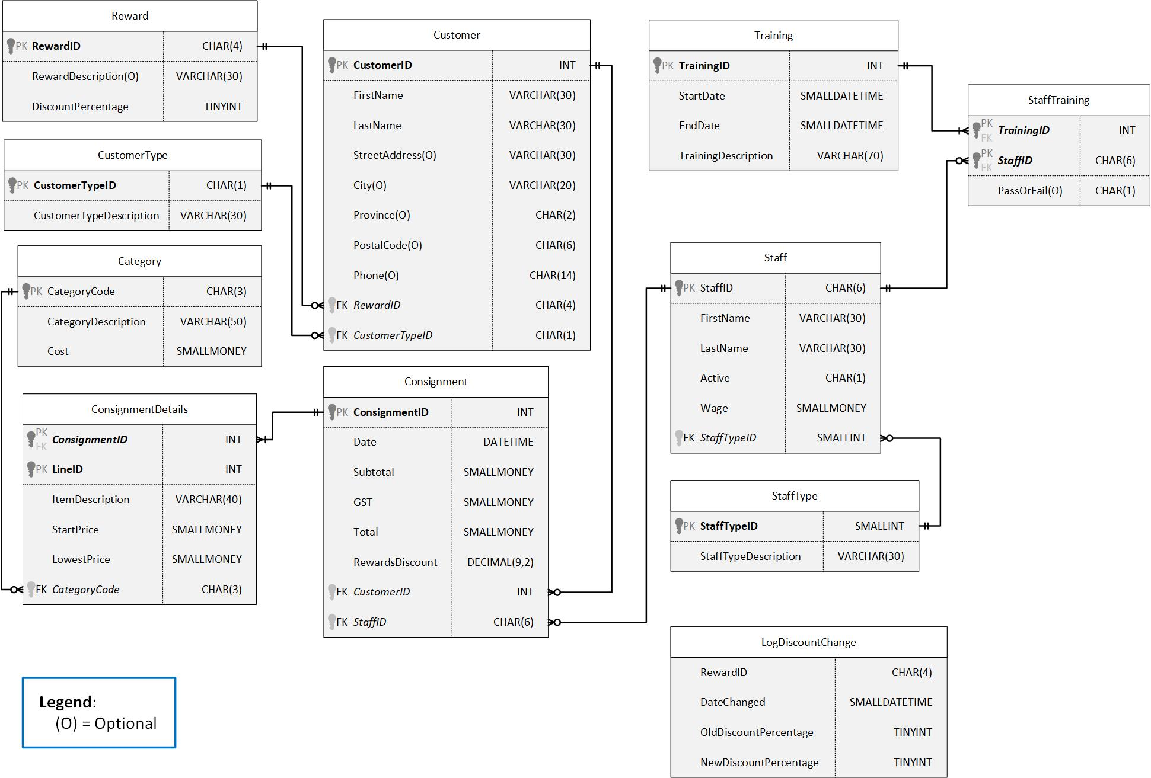

**Submission Requirements**

Lab Submission will include the following:

* A single script file submitted to Moodle called “Lab4_LastName_FirstName.sql” that contains all the trigger code with drop trigger statements at the **top** of the script
  + Use SQL comments to label and separate each trigger **clearly**
  + No test data, random comments or commented out code should be included
* At the beginning of your SQL script file, add a comment block with a **short** discussion about the lab including:
  + What you liked/disliked about the lab
  + How long it took you to complete the lab
  + How prepared you felt you were for the lab
  + If there are any known errors in your solution, please identify them in your discussion. Errors you have identified and simply could not find a solution for are more acceptable than undocumented errors ☺.
* Any additional requirements as specified by your instructor.
* **SELECT * is NOT acceptable anywhere in your lab submission**

**Other Considerations**

**This is not a group project. Working too closely with another student on lab material will result in a grade of zero (0) for both students**. Up to 3 Marks may be deducted for incomplete/incorrect lab submission. Please ask if you are unsure of any lab requirements.

**Moodle Mark**

Your mark on Moodle is a percentage, i.e., $Mark=\frac{x}{12.5}×100$. Instructor’s spreadsheet records the mark out of 12.5.